DETHIANH.COM  Miễn phí - Đề thi thử số 2  Cập nhật ngày 16/05/2025 | HÀ NỘI | ĐỀ THI THỬ VÀO LỚP 10 NĂM 2025  MÔN: TIẾNG ANH  Thời gian làm bài 60 phút, không kể thời gian phát đề.  _____

Part 1. Choose the word whose underlined part differs from that of the other three in pronunciation in each of the following questions.
Question 1: | A. hardw|a|re | B. c|a|rry | C. ch|a|llenge | D. imp|a|ct
Question 2: | A. di|s|order | B. as|s|istance | C. po|s|ition | D. |s|erious

Part 2. Choose the word that differs from the other three in the position of primary stress in each of the following questions.
Question 3: | A. laughter | B. famous | C. pattern | D. explore
Question 4: | A. recipe | B. expected | C. exactly | D. sensation

Part 3. Choose the correct answer to each of the following questions.
Question 5: | After the forest fire, the once lush landscape was a ______ wasteland.
 | A. peaceful | B. crowded | C. desolate | D. vibrant
Question 6: | He ______ a bicycle for his birthday last year.
 | A. got | B. get | C. gets | D. was getting
Question 7: | Da Nang is considered ______ modern as any other coastal city in Vietnam.
 | A. so | B. as | C. more | D. most
Question 8: | If they ______ us about their culture, we ______ more understanding.
 | A. taught - will have | B. teach - will have | C. taught - would have | D. teach - would have
Question 9: | Mai's host family gave her a lovely birthday present.  Mai: "This is such a thoughtful gift! Thank you so much, Mrs. Smith."  Mrs. Smith: "______"
 | A. Oh, it was nothing special. | B. Don't worry about it. | C. You're very welcome, Mai. We're so glad you like it. | D. It's just a small something.
Question 10: | Do you remember the day ______ we first met?
 | A. where | B. that | C. when | D. which
Question 11: | The smell of freshly baked bread was so ______ that I had to buy a loaf.
 | A. valuable | B. tempting | C. enormous | D. careful
Question 12: | ______ dogs enjoy playing fetch in the park.
 | A. Most | B. Almost all of the | C. The majority of the | D. Many of

Part 4. Read the following instruction and choose the correct option that best fits each of the numbered blanks from 13 to 16.

HOW TO BUILD SELF-DISCIPLINE
1. Set clear and (13) ______ goals for yourself.
2. Break down large tasks (14) ______ smaller, manageable steps.
3. Eliminate distractions and create (15) ______ productive environment.
4. Practice self-control and resist the urge to (16) ______.
5. Track your progress and celebrate your successes.
6. Don't be afraid to ask for support from others.

Question 13: | A. achieved | B. achieving | C. achievable | D. achieve
Question 14: | A. with | B. into | C. over | D. for
Question 15: | A. x (no article) | B. the | C. a | D. an
Question 16: | A. procrastinate | B. procrastinated | C. procrastinating | D. procrastination

Part 5. Choose the correct answer to each of the following questions from 17 to 18.

Question 17: | Choose the correct order of sentences a, b, and c.
The Slurping Soup
Lunch at my friend's house was a learning experience, to say the least.
a. His mother smiled and explained that in their culture, it was a sign of enjoyment.
b. We sat down to a delicious-smelling bowl of noodle soup.
c. My friend, unaware of my discomfort, began loudly slurping his soup.
 | A. b - c - a | B. c - b - a | C. a - c - b | D. b - a - c
Question 18: | Choose the sentence that most appropriately ends the text in Question 17.
A. I politely asked for a spoon, hoping to avoid any further embarrassment.
B. I realized that table manners can vary greatly around the world.
C. The soup was indeed delicious, despite the unusual way of eating it.
D. I tried it myself, feeling a little awkward but also understanding a new custom.

Part 6. Choose the correct option that best fits each of the numbered blanks from 19 to 24.

Understanding the Human Brain
The human brain is an incredibly complex organ responsible for everything we think, feel, and do. It controls our voluntary actions like walking and talking, (19) ______ also our involuntary actions like breathing and heartbeat. (20) ______ amazing fact about the brain is its ability to constantly adapt and change throughout our lives, a process known as neuroplasticity.
This means that we can learn new skills, form new memories, and even recover from (21) ______ brain injuries. Scientists are still working to understand the full potential of the brain, but one thing is clear: (22) ______ is no other organ quite like it. Learning about how our brains work can help us make better decisions, improve our memory, and even boost our creativity. (23) ______ , understanding the brain can empower us to live healthier, happier, and more fulfilling lives. (24) ______ to learn more about this incredible organ?

Question 19: | A. and | B. so | C. but | D. because
Question 20: | A. Other | B. Another | C. One | D. Any
Question 21: | A. little | B. much | C. some | D. any
Question 22: | A. it | B. this | C. that | D. there
Question 23: | A. Ultimately | B. However | C. Because | D. Although
Question 24: | A. Ready are you | B. Ready you are | C. Are you ready | D. You are ready

Part 7. Choose the sentence that is CLOSEST in meaning to the original sentence in each of the following questions.

Question 25: | "I was studying English last night when you called," he said.
A. He said that he had been studying English the previous night when I called.
B. He said that I was studying English last night when he called.
C. He said that he was studying English last night when I called.
D. He said that I had been studying English the previous night when he called.
Question 26: | It's essential to get enough sleep before a big test.
A. Before a big test, getting enough sleep is essential.
B. Getting enough sleep before a big test, which is essential.
C. Why is getting enough sleep before a big test essential?
D. Ensure you are well-rested before taking an important exam.

Part 8. Choose the sentence that is made from the given cues in each of the following questions.

Question 27: | I / encourage / everyone / participate / upcoming event.
A. I encourage everyone for participation in the upcoming event.
B. I encourage everyone to participate in the upcoming event.
C. I encourage everyone to participate on the upcoming event.
D. I encourage everyone participating in the upcoming event.
Question 28: | Minh / love / play basketball / friends / school.
A. Minh loves play basketball with his friend after school.
B. Minh loving playing basketball to his friends after school.
C. Minh loves playing basketball with his friends after school.
D. Minh loves playing basketball with his friends at school.

Part 9. Read the following sign or notice and choose the correct answer to each of the following questions.

Question 29: | You are driving down a residential street and see the sign below. What should you do?
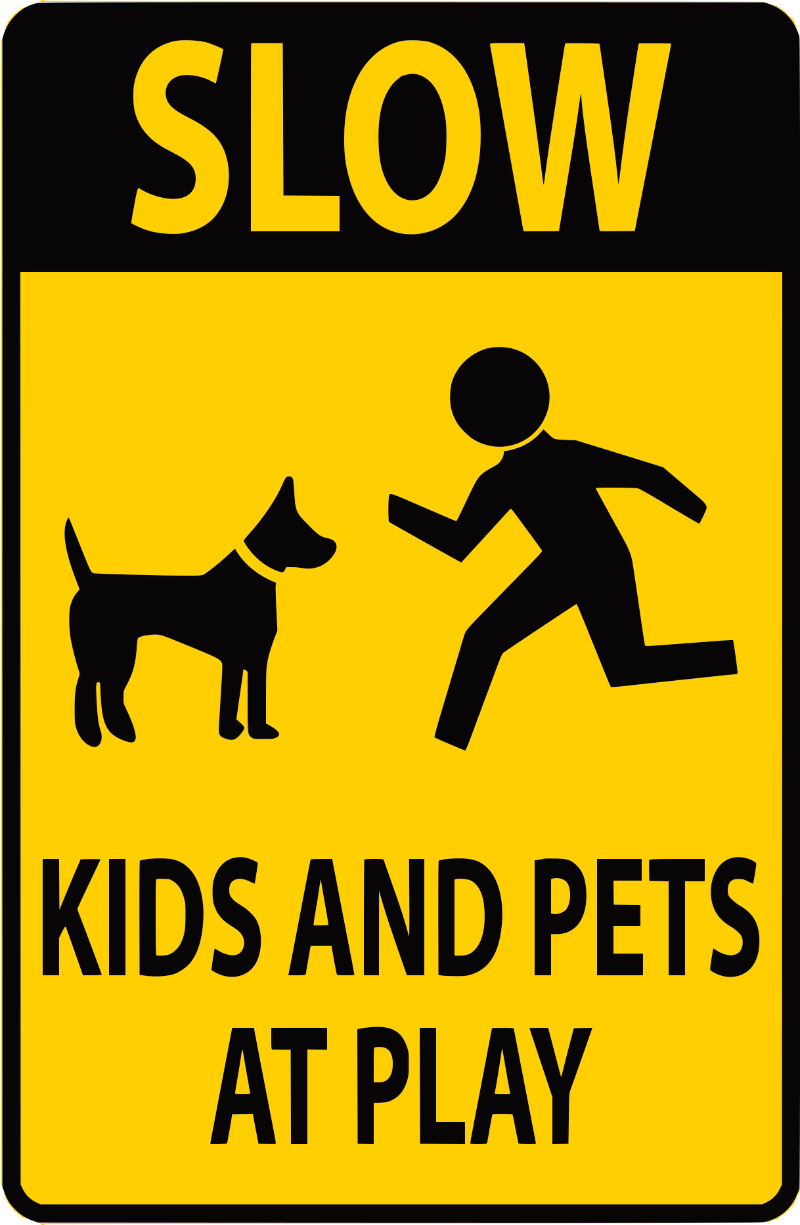 |  |  |  |  | A. Drive slowly and be careful because children and animals might be playing near the road.  B. Stop your car and wait for kids and pets to move.  C. Honk your horn to warn the kids and pets.  D. There are kids and pets crossing the road ahead.
Question 30: | When might you be charged a fee?
We understand that emergencies happen. However, missing your appointment without prior notice may incur a charge. |  |  |  |  | A. If you forget to bring your insurance card.  B. If you reschedule your appointment with short notice.  C. If you don't show up and don't inform the office.  D. If you arrive late to your appointment.

Part 10. Read the following passage and choose the correct answer to each of the following questions from 31 to 36.

While the LEGO Group was founded in 1932, the |iconic| LEGO brick we know today wasn't introduced until 1958. This revolutionary design, featuring studs and tubes underneath, allowed for secure interlocking and endless building possibilities. This simple yet ingenious invention quickly gained popularity, captivating children and adults alike.
The success of the LEGO brick can be attributed to its versatility. Unlike traditional toys that limit play to specific scenarios, LEGO bricks offer open-ended play, encouraging creativity and imagination. Children can construct anything they envision, from houses and cars to spaceships and robots. This limitless potential for creativity is central to LEGO's enduring appeal.
LEGO's popularity extends far beyond simple building toys. The brand has successfully expanded into the digital world with video games, animated movies, and even educational software. These multimedia ventures often incorporate problem-solving elements and promote collaborative play, reflecting the core values found in traditional LEGO building.
Despite facing competition from digital entertainment, LEGO remains a beloved and |enduring| toy. Its ability to adapt to changing trends, embrace new technologies, and, most importantly, continue sparking creativity ensures that LEGO bricks will likely remain a staple in playrooms for generations to come.

Question 31: | What is the main topic of the reading passage?
A. The design and production of LEGO bricks.
B. The history and continued popularity of LEGO.
C. The differences between LEGO and other building toys.
D. The various LEGO video games and movies available.
Question 32: | The word "iconic" in paragraph 1 is CLOSEST in meaning to ______.
 | A. complex | B. famous | C. recent | D. colorful
Question 33: | What feature of LEGO bricks is highlighted as being key to their success?
 | A. Their ability to be joined together in many ways. | B. Their bright colors and attractive designs. | C. Their connection to popular movies and characters. | D. Their low cost and availability in stores.
Question 34: | Which of these is NOT mentioned as a way LEGO has expanded its brand?
 | A. Developing video games. | B. Creating educational software. | C. Producing animated movies. | D. Creating LEGO themed clothing lines.
Question 35: | What does the author believe about the future of LEGO?
A. LEGO will soon be replaced by digital toys.
B. LEGO should focus only on traditional building bricks.
C. LEGO needs to change drastically to survive.
D. LEGO will remain popular for many years.
Question 36: | The word "enduring" in paragraph 4 is OPPOSITE in meaning to ______.
 | A. temporary | B. widespread | C. lasting | D. significant

Part 11. Four phrases/sentences have been removed from the text below. For each question, choose A, B, C, or D to indicate the correct option that best fits each of the numbered blanks from 37 to 40.

France is renowned worldwide for its exceptional cuisine, and at the heart of this culinary legacy lies its exquisite baking tradition. From crusty baguettes to delicate pastries, French baking (37) ______ that has captivated taste buds for centuries.
One of the cornerstones of French baking is the emphasis on using high-quality, fresh ingredients. (38) ______, flour, butter, and sugar are carefully selected to ensure optimal flavor and texture in every creation. French bakers believe that using the finest ingredients is crucial for achieving the desired taste and consistency.
The art of French baking extends far beyond simple bread and pastries. (39) ______, showcasing both sweet and savory flavors. From buttery croissants to elaborate fruit tarts and delicate macarons, French baking offers an extensive repertoire of treats to satisfy every palate.
(40) ______, French baking represents a true testament to the country's dedication to culinary excellence. It is a tradition that continues to inspire and delight food enthusiasts around the globe.
A. It encompasses a wide variety of baked goods
B. With its meticulous techniques and dedication to quality
C. Whether it's traditional baguettes or delicate pastries
D. is a time-honored art form

Question 37: __________ | Question 38: __________ | Question 39: __________ | Question 40: __________

------------------------------ THE END ------------------------------

ĐÁP ÁN

Câu | 1 | 2 | 3 | 4 | 5 | 6 | 7 | 8 | 9 | 10
Chọn | A | C | D | A | C | A | B | C | C | C
Câu | 11 | 12 | 13 | 14 | 15 | 16 | 17 | 18 | 19 | 20
Chọn | B | A | C | B | C | A | A | D | C | B
Câu | 21 | 22 | 23 | 24 | 25 | 26 | 27 | 28 | 29 | 30
Chọn | C | D | A | C | A | D | B | C | A | C
Câu | 31 | 32 | 33 | 34 | 35 | 36 | 37 | 38 | 39 | 40
Chọn | B | B | A | D | D | A | D | C | A | B

