DETHIANH.COM  Miễn phí - Đề thi thử số 8  Cập nhật ngày 16/05/2025 | HÀ NỘI | ĐỀ THI THỬ VÀO LỚP 10 NĂM 2025  MÔN: TIẾNG ANH  Thời gian làm bài 60 phút, không kể thời gian phát đề.  _____

Part 1. Choose the word whose underlined part differs from that of the other three in pronunciation in each of the following questions.
Question 1: | A. actr|e|ss | B. abs|e|nce | C. paym|e|nt | D. r|e|act
Question 2: | A. o|th|erwise | B. |th|erefore | C. no|th|ing | D. ano|th|er

Part 2. Choose the word that differs from the other three in the position of primary stress in each of the following questions.
Question 3: | A. protect | B. contract | C. debate | D. unfold
Question 4: | A. clinical | B. satisfy | C. consultant | D. furniture

Part 3. Choose the correct answer to each of the following questions.
Question 5: | The movie's tragic ending left the audience feeling deeply ______.
 | A. indifferent | B. saddened | C. inspired | D. amused
Question 6: | The concert ______ at 7:00 PM and ______ at 10:00 PM.
 | A. is starting, is finishing | B. will start, will finish | C. started, finished | D. starts, finishes
Question 7: | The Nile River is considered by many to be ______ river in the world.
 | A. the longest | B. long | C. longer | D. most long
Question 8: | If he ______ to himself, he ______ the courage to follow his dreams.
 | A. listened - would find | B. listened - will have found | C. had listened - would have found | D. had listened - will find
Question 9: | Nam is opening a birthday gift from his classmate, David.  Nam: "Wow, this watch is amazing! Thank you so much, David!"  David: "______"
 | A. Don't mention it. It was nothing. | B. Yes, it's quite expensive. | C. You're welcome, Nam. I'm glad you like it! | D. Oh, you shouldn't have.
Question 10: | We can go hiking or swimming. Which activity, ______ sounds more fun to you?
 | A. that | B. which | C. who | D. where
Question 11: | The news of his scholarship brought a ______ smile to his face.
 | A. sleepy | B. radiant | C. blank | D. familiar
Question 12: | The garden has ______ flowers in bloom.
 | A. a wide variety of | B. very beautiful | C. many of | D. a much

Part 4. Read the following instruction and choose the correct option that best fits each of the numbered blanks from 13 to 16.

HOW TO CREATE A STRONG PASSWORD
1. A strong password should be (13) ______ least 12 characters long.
2. It's better if it's longer.
3. Include (14) ______ mix of upper and lowercase letters, numbers, and symbols.
4. Don't use personal information that could be easily (15) ______.
5. Avoid common words or phrases in your password.
6. And never share your password with (16) ______!

Question 13: | A. with | B. for | C. in | D. at
Question 14: | A. a | B. an | C. x (no article) | D. the
Question 15: | A. guess | B. to guess | C. guessed | D. guessing
Question 16: | A. everyone | B. anyone | C. no one | D. someone

Part 5. Choose the correct answer to each of the following questions from 17 to 18.

Question 17: | Choose the correct order of sentences a, b, and c.
The Wrong Order
I went to a new cafe near my house to buy a takeaway iced coffee.
a. When I received my drink, it was a regular latte with regular milk.
b. I politely pointed out the mistake to the barista, showing him my receipt.
c. I clearly ordered a caramel macchiato with oat milk from the barista.
 | A. b - a - c | B. c - b - a | C. c - a - b | D. a - c - b
Question 18: | Choose the sentence that most appropriately ends the text in Question 17.
A. He apologized for the mix-up and quickly prepared the correct order for me.
B. He gave me a blank stare, seemingly confused by my complaint.
C. He shrugged and said they were out of oat milk and caramel syrup.
D. He insisted that I had ordered a latte and refused to change it.

Part 6. Choose the correct option that best fits each of the numbered blanks from 19 to 24.

Travelling on a Shoestring
Traveling the world doesn't have to break the bank! There are many ways to explore new places on a budget. (19) ______ important tip is to be flexible with your travel dates. Sometimes, flying mid-week or during the off-season can save you (20) ______ money on flights and accommodation. (21) ______, consider staying in hostels or guesthouses instead of expensive hotels.
(22) ______ your meals can also help you save. Eating at local markets or trying street food is not only cheaper than restaurants but also a great way (23) ______ the local culture. (24) ______, walking or using public transportation instead of taxis can significantly reduce your expenses and give you a more authentic experience. Remember, with a little planning and creativity, you can have an amazing trip without spending a fortune.

Question 19: | A. One | B. The | C. An | D. A
Question 20: | A. many | B. much | C. a few | D. a lot of
Question 21: | A. Additionally | B. Because | C. So | D. Although
Question 22: | A. Cooked | B. To cook | C. Cook | D. Cooking
Question 23: | A. experiencing | B. for experiencing | C. experience | D. to experience
Question 24: | A. Despite | B. Finally | C. However | D. Because

Part 7. Choose the sentence that is CLOSEST in meaning to the original sentence in each of the following questions.

Question 25: | "We'll be flying to Hanoi this time next week," they said.
A. They said that they would be flying to Hanoi this time next week.
B. They said that we would be flying to Hanoi that time the following week.
C. They said that they will be flying to Hanoi this time next week.
D. They said that they would be flying to Hanoi that time the following week.
Question 26: | I believe that hard work leads to success.
A. Hard work, I believe, is leading to success.
B. To my mind, hard work leads to success.
C. I believe in working hard to lead to success.
D. To have success, I believe in hard work.

Part 8. Choose the sentence that is made from the given cues in each of the following questions.

Question 27: | I / look / some old photos / find / this one / us.
A. I was looking through some old photos and found this one of us.
B. I was look through some old photos and found this one with us.
C. I was looking some old photos and find this one of us.
D. I looked through some old photos and finding this one of us.
Question 28: | I / use / eat / rice / every day.
A. I am use to eat rice every day.
B. I am used to eat rice everyday.
C. I am used to eating rice every day.
D. I used to eating rice every day.

Part 9. Read the following sign or notice and choose the correct answer to each of the following questions.

Question 29: | You are working at a construction site. You see the sign below on a door. What does this sign mean?
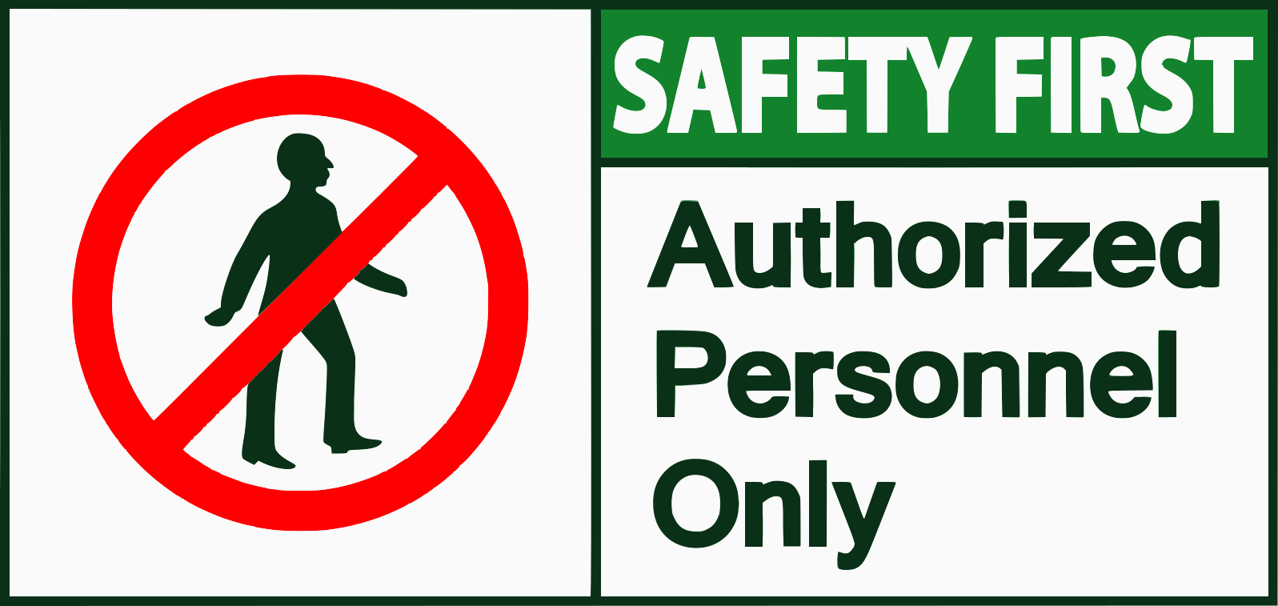 |  |  |  |  | A. Only workers who are allowed to enter can go through this door.  B. No one is allowed to enter this area.  C. Only people wearing safety gear can enter.  D. Everyone should prioritize safety when entering this area.
Question 30: | What can you infer from this notice?
Bake Sale - All proceeds go to the local animal shelter. |  |  |  |  | A. You can adopt animals at the bake sale.  B. All the money from the bake sale will be donated.  C. The animal shelter is selling baked goods.  D. Buying baked goods will help animals in need.

Part 10. Read the following passage and choose the correct answer to each of the following questions from 31 to 36.

The mid-19th century saw the rise of portrait photography, a genre quickly |embraced| by the public. Before this innovation, painted portraits were the only way to capture a person's likeness, a luxury reserved for the wealthy. The daguerreotype, an early photographic process, offered a faster and more affordable alternative.
Introduced in 1839, the daguerreotype used a silver-plated copper sheet treated with chemical fumes to create a highly detailed, one-of-a-kind image. Although significantly cheaper than a painted portrait, the process was still relatively expensive for the average person. Studios emerged offering specialized services like posing chairs and flattering lighting to enhance these treasured keepsakes.
The introduction of the carte de visite in the 1850s revolutionized portrait photography. This process used paper prints, allowing for multiple copies from a single negative, making photography accessible to a wider audience. People began collecting and exchanging cartes de visite, and photographers started specializing in portraits of famous individuals, further increasing their popularity.
This surge in portrait photography's popularity wasn't without criticism. Some argued that the pursuit of a 'good likeness' overshadowed artistic expression. Others questioned the ethics of readily replicating images, potentially |diminishing| the value of the individual portrayed. However, the accessibility and affordability of photography solidified its place in society, forever changing the way we capture and perceive ourselves and each other.

Question 31: | What is the main idea of the reading passage?
A. The social impact of photographic portraiture on different classes.
B. The technical aspects of the daguerreotype photographic process.
C. The rise in popularity and evolution of portrait photography during the mid-19th century.
D. The artistic merits of painted portraits versus photographic portraits.
Question 32: | The word "embraced" in paragraph 1 is CLOSEST in meaning to ______.
 | A. ignored | B. welcomed | C. rejected | D. criticized
Question 33: | What made the carte de visite different from the daguerreotype?
 | A. It required specialized studios with elaborate equipment. | B. It used a silver-plated copper sheet for a more detailed image. | C. The ability to produce multiple prints from one image. | D. It was more expensive and catered exclusively to the wealthy.
Question 34: | Which of these is NOT mentioned as a criticism of portrait photography?
 | A. The focus on realistic representation over artistic expression. | B. The use of artificial lighting techniques. | C. The potential devaluation of the individual being photographed. | D. The ethical implications of easily reproduced images.
Question 35: | What was the main impact of the carte de visite on portrait photography?
A. It led to the decline of painted portraits as a form of art.
B. It created controversy about the use of chemicals in photography.
C. It encouraged photographers to experiment with abstract techniques.
D. It made photography affordable and accessible to a wider public.
Question 36: | The word "diminishing" in paragraph 4 is OPPOSITE in meaning to ______.
 | A. lowering | B. weakening | C. reducing | D. increasing

Part 11. Four phrases/sentences have been removed from the text below. For each question, choose A, B, C, or D to indicate the correct option that best fits each of the numbered blanks from 37 to 40.

Imagine a future where traffic jams are a distant memory, and commuting involves soaring above congested roads. This is the promise of flying cars, a concept that has captivated futurists and entrepreneurs for decades. (37) ______, significant technological advancements are bringing this vision closer to reality.
One of the main challenges facing flying car development is battery technology. (38) ______. However, recent breakthroughs in battery energy density and charging infrastructure are paving the way for electric vertical take-off and landing (eVTOL) aircraft, essentially flying cars with multiple rotors.
(39) ______. These vehicles combine the convenience of personal automobiles with the speed and efficiency of air travel, potentially revolutionizing urban mobility. Imagine bypassing rush hour traffic by simply taking to the skies!
While challenges remain, such as regulatory hurdles and public acceptance, the rapid pace of innovation suggests that flying cars could become a viable transportation option in the not-too-distant future. (40) ______, reducing our dependence on traditional road networks.
A. This would ease congestion and decrease travel times
B. While still in its early stages
C. Current batteries lack the power and range for extended flights.
D. These eVTOLs offer a glimpse into a future of personalized air travel.

Question 37: __________ | Question 38: __________ | Question 39: __________ | Question 40: __________

------------------------------ THE END ------------------------------

ĐÁP ÁN

Câu | 1 | 2 | 3 | 4 | 5 | 6 | 7 | 8 | 9 | 10
Chọn | D | C | B | C | B | D | A | C | C | B
Câu | 11 | 12 | 13 | 14 | 15 | 16 | 17 | 18 | 19 | 20
Chọn | B | A | D | A | C | B | C | A | A | D
Câu | 21 | 22 | 23 | 24 | 25 | 26 | 27 | 28 | 29 | 30
Chọn | A | D | D | B | D | B | A | C | A | D
Câu | 31 | 32 | 33 | 34 | 35 | 36 | 37 | 38 | 39 | 40
Chọn | C | B | C | B | D | D | B | C | D | A

