DETHIANH.COM  Miễn phí - Đề thi thử số 9  Cập nhật ngày 16/05/2025 | HÀ NỘI | ĐỀ THI THỬ VÀO LỚP 10 NĂM 2025  MÔN: TIẾNG ANH  Thời gian làm bài 60 phút, không kể thời gian phát đề.  _____

Part 1. Choose the word whose underlined part differs from that of the other three in pronunciation in each of the following questions.
Question 1: | A. ref|u|se | B. |u|nknown | C. s|u|mmer | D. st|u|mble
Question 2: | A. thanks|g|iving | B. tra|g|ic | C. le|g|ally | D. dra|g|on

Part 2. Choose the word that differs from the other three in the position of primary stress in each of the following questions.
Question 3: | A. permit | B. instruct | C. contact | D. prepare
Question 4: | A. sacrifice | B. destruction | C. restaurant | D. classify

Part 3. Choose the correct answer to each of the following questions.
Question 5: | He finds playing the guitar incredibly ______, especially after a long day at school.
 | A. demanding | B. tiresome | C. therapeutic | D. challenging
Question 6: | We ______ to the beach tomorrow if the weather is nice.
 | A. are going | B. go | C. went | D. will go
Question 7: | Autumn in Hanoi is often considered ______ season of the year.
 | A. as pleasant | B. the most pleasant | C. pleasant | D. more pleasant
Question 8: | He ______ more friends if he ______ so shy.
 | A. would have - weren't | B. had - won't be | C. will have - isn't | D. has - wasn't
Question 9: | It's Hoa's birthday, and she's invited her classmate, Charlotte, to her party.  Hoa: "I'm having a small birthday get-together on Saturday. I'd love for you to come!"  Charlotte: "______"
 | A. A party? I'm not sure if I'm free then. | B. Thanks for inviting me, but I have other plans. | C. That's so kind of you! I wouldn't miss it. | D. That sounds like fun, but I might be busy.
Question 10: | He didn't tell me the reason ______ he was late for our meeting.
 | A. why | B. how | C. where | D. which
Question 11: | Everyone was ______ by Minh's unexpected win at the talent show.
 | A. enormous | B. stunned | C. blurry | D. tired
Question 12: | I need ______ reassurance that everything will be alright.
 | A. few | B. a bit of | C. a little | D. many

Part 4. Read the following instruction and choose the correct option that best fits each of the numbered blanks from 13 to 16.

HOW TO DEAL WITH NEGATIVE THOUGHTS
1. Acknowledge the thought without judgment. Don't push it (13) ______.
2. Challenge (14) ______ negative thought. Is it really true?
3. (15) ______ it with a positive or neutral thought.
4. Focus on your strengths and past successes.
5. Talk to someone you trust, like a friend or family member, about your (16) ______.

Question 13: | A. in | B. aside | C. down | D. away
Question 14: | A. x (no article) | B. a | C. the | D. an
Question 15: | A. Replace | B. Forget | C. Bury | D. Ignore
Question 16: | A. feelings | B. problems | C. issues | D. anxieties

Part 5. Choose the correct answer to each of the following questions from 17 to 18.

Question 17: | Choose the correct order of sentences a, b, and c.
Volunteer Activity Choice
Our class was choosing between two volunteer activities: visiting an orphanage or cleaning a local park.
a. I strongly felt cleaning the park would have a direct impact on our community.
b. My friend, however, believed spending time with orphans was more meaningful.
c. Both options were worthwhile, making the decision difficult.
 | A. c - a - b | B. c - b - a | C. b - c - a | D. b - a - c
Question 18: | Choose the sentence that most appropriately ends the text in Question 17.
A. It was frustrating that we couldn't agree, wasting valuable class time.
B. We eventually agreed to clean the park, since it required less time.
C. We respectfully presented our reasoning, understanding the value of both perspectives.
D. Ultimately, the teacher decided we would visit the orphanage that weekend.

Part 6. Choose the correct option that best fits each of the numbered blanks from 19 to 24.

Harnessing the Wind
The wind is a powerful force of nature. It can be destructive, like (19) ______ a hurricane, but it can also be (20) ______. For centuries, people have used windmills to harness the power of the wind. These structures use large blades (21) ______ the wind's energy into mechanical energy. This energy was traditionally used for tasks like grinding grain or pumping water, (22) ______ today, it is primarily used to generate electricity.
Wind energy offers (23) ______ benefits over traditional fossil fuels. First, it is a renewable resource, meaning it will never run out. Second, it is a clean source of energy that does not produce harmful emissions. (24) ______, it can be harnessed in various locations, from open plains to offshore areas, making it a versatile energy solution.

Question 19: | A. with | B. during | C. for | D. on
Question 20: | A. useful incredibly | B. incredibly useful | C. incredibly use | D. use incredibly
Question 21: | A. to capture | B. capture | C. capturing | D. for capture
Question 22: | A. and | B. so | C. but | D. because
Question 23: | A. little | B. much | C. several | D. any
Question 24: | A. Despite | B. However, | C. Furthermore, | D. Although

Part 7. Choose the sentence that is CLOSEST in meaning to the original sentence in each of the following questions.

Question 25: | "We were planning our vacation for next month," they announced.
A. They announced that we had been planning our vacation for next month.
B. They announced that they had been planning their vacation for the following month.
C. They announced that they were planning their vacation for the following month.
D. They announced that they had been planning their vacation for next month.
Question 26: | I think you should study harder for the upcoming exam.
A. How about study harder for the upcoming exam?
B. You should consider studying harder for the upcoming exam.
C. Why you not study harder for the upcoming exam?
D. I think studying harder for the upcoming exam is good.

Part 8. Choose the sentence that is made from the given cues in each of the following questions.

Question 27: | What / this symbol / stand
A. What this symbol stand for?
B. What is this symbol stand for?
C. What does this symbol stand for?
D. What do this symbol stand for?
Question 28: | We / commit / improve / English skills.
A. We are committed to improving our English skills.
B. We are committed to improvement of English skills.
C. We committing to improve our English skills.
D. We are commit to improving our English skill.

Part 9. Read the following sign or notice and choose the correct answer to each of the following questions.

Question 29: | You are walking home from school and see the sign below posted on a fence. What does this sign tell you?
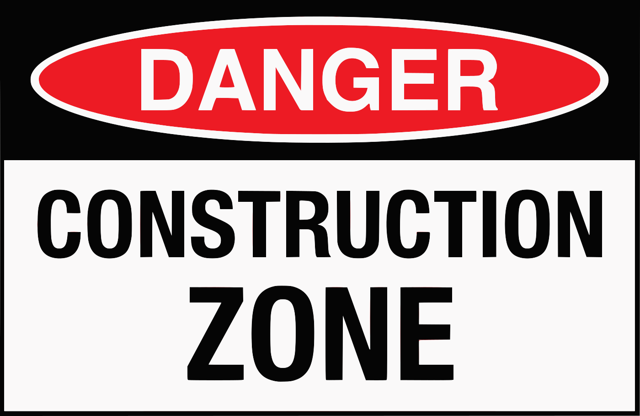 |  |  |  |  | A. This area is dangerous because there is construction work happening.  B. This sign is black, red, and white with the words "Danger" and "Construction Zone."  C. This sign shows there is a danger of falling tools.  D. You should be careful when entering this zone because of the construction workers.
Question 30: | What can you infer from this website notice?
This website is currently under construction. |  |  |  |  | A. The website is undergoing a redesign process.  B. The website is still being developed and may be incomplete.  C. The website is experiencing technical difficulties.  D. The website is unavailable for public access.

Part 10. Read the following passage and choose the correct answer to each of the following questions from 31 to 36.

Nebulae, vast clouds of gas and dust scattered throughout our galaxy, are not only visually stunning but also play a |crucial| role in the lifecycle of stars. These celestial nurseries are broadly categorized into different types based on their formation and characteristics.
Emission nebulae, as their name suggests, emit their own light due to the ionization of gases within them. Typically red in color due to the abundance of hydrogen, they are often associated with regions of active star formation. In contrast, reflection nebulae do not emit light themselves but rather reflect the light of nearby stars, often appearing blue due to the scattering of shorter wavelengths.
Another type, dark nebulae, are dense clouds of dust and gas that block light from background stars, appearing as dark patches against the brighter backdrop of the Milky Way. These regions are extremely cold and dense, making them ideal locations for the gravitational collapse that leads to star birth.
Understanding the characteristics of different nebulae types provides valuable |insights| into the processes of star formation and the evolution of galaxies. Further studies using advanced telescopes promise even deeper insights into these fascinating cosmic objects.

Question 31: | What is the main topic of this reading passage?
A. The composition of the Milky Way galaxy.
B. Different types and characteristics of nebulae.
C. The history of astronomical observations.
D. The formation of stars and planets.
Question 32: | The word "crucial" in paragraph 1 is CLOSEST in meaning to ______.
 | A. unimportant | B. challenging | C. essential | D. complex
Question 33: | Why do emission nebulae appear red?
 | A. They reflect the light of nearby red stars. | B. They are moving away from us at high speed. | C. They absorb all other colors except red. | D. They contain a large amount of hydrogen gas.
Question 34: | Which type of nebulae is NOT directly mentioned in the text?
 | A. Emission nebulae | B. Planetary nebulae | C. Reflection nebulae | D. Dark nebulae
Question 35: | According to the passage, what makes dark nebulae suitable for star formation?
A. Their proximity to bright stars.
B. Their ability to emit light.
C. Their large size and irregular shape.
D. Their low temperature and high density.
Question 36: | The word "insights" in paragraph 4 is OPPOSITE in meaning to ______.
 | A. observations | B. discoveries | C. misunderstandings | D. knowledge

Part 11. Four phrases/sentences have been removed from the text below. For each question, choose A, B, C, or D to indicate the correct option that best fits each of the numbered blanks from 37 to 40.

The rise of cooking shows and food blogs in recent years is (37) ______ a shift in how we view food and cooking. What was once considered a mundane necessity has transformed into a source of entertainment, education, and inspiration.
Cooking shows, with their charismatic chefs and delectable dishes, have made the culinary world more accessible. (38) ______. Food blogs, on the other hand, offer a platform for both amateur and professional food enthusiasts to share their recipes, tips, and stories.
This increased visibility has fostered a sense of community around food. (39) ______, learning new techniques, and sharing culinary experiences with people from all walks of life. The internet has become a melting pot of flavours and ideas, dissolving geographical boundaries and bringing people together through their shared love of food.
Ultimately, this phenomenon signifies more than just a passing trend. (40) ______, encouraging culinary experimentation, and promoting healthier eating habits.
A. They demystify complex cooking processes, making gourmet cuisine achievable even for beginners.
B. It's about empowering individuals to become more confident cooks
C. a testament to
D. People connect online by exchanging recipes

Question 37: __________ | Question 38: __________ | Question 39: __________ | Question 40: __________

------------------------------ THE END ------------------------------

ĐÁP ÁN

Câu | 1 | 2 | 3 | 4 | 5 | 6 | 7 | 8 | 9 | 10
Chọn | A | B | C | B | C | D | B | A | C | A
Câu | 11 | 12 | 13 | 14 | 15 | 16 | 17 | 18 | 19 | 20
Chọn | B | B | D | C | A | A | A | C | B | B
Câu | 21 | 22 | 23 | 24 | 25 | 26 | 27 | 28 | 29 | 30
Chọn | A | C | C | C | B | B | C | A | A | B
Câu | 31 | 32 | 33 | 34 | 35 | 36 | 37 | 38 | 39 | 40
Chọn | B | C | D | B | D | C | C | A | D | B

