DETHIANH.COM  Miễn phí - Đề thi thử số 1  Cập nhật ngày 16/05/2025 | TPHCM | ĐỀ THI THỬ VÀO LỚP 10 NĂM 2025  MÔN: TIẾNG ANH  Thời gian làm bài 90 phút, không kể thời gian phát đề.  _____

Part 1. Choose the word / phrase / sentence that best fits the space or best answers the question given in each sentence.
Question 1: | Which word has the underlined part pronounced differently from that of the others?
 | A. prof|i|t | B. w|i|nner | C. traff|i|c | D. des|i|re
Question 2: | Which word has the underlined part pronounced differently from that of the others?
 | A. direc|t|or | B. at|t|ention | C. cul|t|ural | D. coun|t|y
Question 3: | Which word has a different stress pattern from that of the others?
 | A. bother | B. appoint | C. depict | D. install
Question 4: | Which word has a different stress pattern from that of the others?
 | A. collector | B. actual | C. arrival | D. illusion
Question 5: | Teacher: Climate change is a complex issue with no easy solutions, ______ it requires a global effort to mitigate its effects.  Student: So, individual actions alone aren't enough?
 | A. but | B. so | C. and | D. for
Question 6: | Adam: Have you ever tried frog legs?  Bill: No way! I'm not really keen ______ trying exotic foods.
 | A. with | B. on | C. to | D. at
Question 7: | Anna: Where did the flapper style originate?  Mary: It came ______ after World War I.
 | A. in | B. about | C. at | D. on
Question 8: | Sarah: I received a strange ______ from someone I don't know. Should I open it?  John: No way! It could be dangerous.
 | A. message | B. song | C. book | D. computer
Question 9: | Chris: I heard they have those new reclining seats in Theater 5.  Alex: Are those the ones ______ have seat warmers too?
 | A. which | B. who | C. that | D. whom
Question 10: | Sarah: Did you see Jennifer's new hairstyle today?  Maria: Yes, I did! Her hair is usually so ______; the change is amazing!
 | A. layered | B. predictable | C. sleek | D. vibrant
Question 11: | Teacher: Let's ______ up where we left off yesterday with the verb conjugations.  Students: Okay!
 | A. read | B. start | C. continue | D. pick
Question 12: | Minh: I took so many pictures of the autumn leaves.  James: That's great! It's important to have a ______ for capturing beauty.
 | A. diet | B. passion | C. schedule | D. neighborhood
Question 13: | John: Have you ever fallen for one of those "too good to be true" online deals?  Mary: ______
 | A. A no from me is that. | B. That's no me from. | C. From me, that's a no. | D. That's a no from me.
Question 14: | Sarah: ______  Emily: Yeah, I spent all day Saturday browsing for new plants.
A. Have you decided what to plant in your garden this year?
B. Are you going to that gardening workshop next month?
C. Did you do anything fun at the farmers' market?
D. Do you need help watering your plants while you're gone?

Part 2. Look at the sign or the notice. Choose the best answer for questions 15 and 16.

Question 15: | You're at a factory tour and see this sign. What should you do?
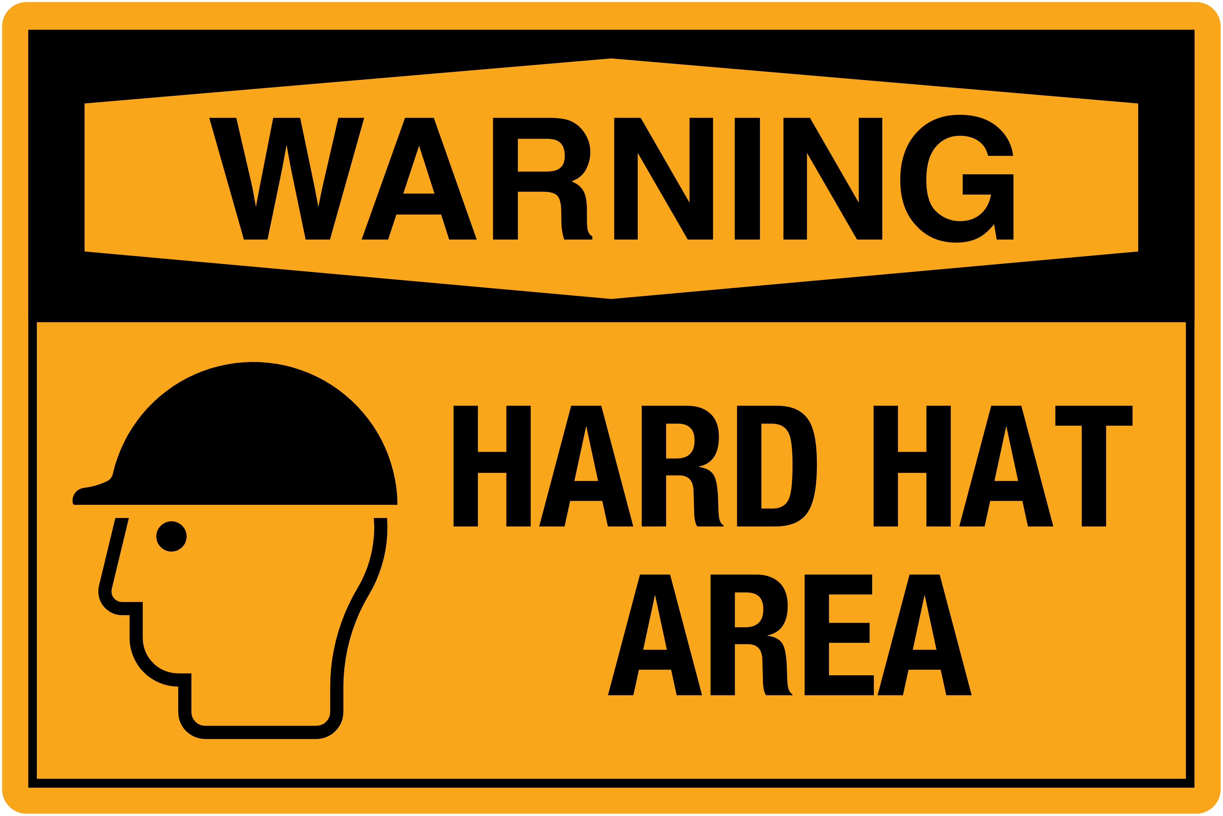 |  |  |  |  | A. You must leave your hat in the designated area.  B. Watch out for falling hard hats in this area.  C. The factory makes hard hats for workers.  D. Make sure you have a hard hat on before entering.
Question 16: | What does the sign say?
Paper towels are so last year! 👋 Join the reusable cloth revolution. 🌿 #SaveTheTrees |  |  |  |  | A. You should recycle paper towels to save trees.  B. You should avoid using anything that comes from trees.  C. You should switch from paper towels to reusable cloths.  D. You should use more paper towels to support the paper industry.

Part 3. Choose the word that best fits each space in the following passage

Dear Sarah,
You won't believe what a (17) ______ day I had at the park! The (18) ______ sunshine and gentle breeze created the perfect atmosphere for a relaxing walk. As I strolled along the (19) ______ path, I (20) ______ so many cute dogs playing fetch with their owners. There were (21) ______ families having picnics on the grass, enjoying the beautiful weather. I even saw a group of children (22) ______ frisbee, their laughter echoing through the park.
I miss you and hope we can go together soon!
Love,
Emily
Question 17: | A. boring | B. lovely | C. quick | D. cloudy
Question 18: | A. warm | B. damp | C. dark | D. harsh
Question 19: | A. crowded | B. winding | C. steep | D. silent
Question 20: | A. will see | B. am seeing | C. see | D. saw
Question 21: | A. little | B. few | C. much | D. several
Question 22: | A. across | B. toward | C. playing | D. under

Part 4. Read the following brochure of a music workshop. Decide whether the statements from 23 to 26 are True or False and choose the correct answer to complete the statements in the question 27 and 28.

Discover the World of Instruments!
This summer, embark on a melodious journey with our immersive instrument workshop! Whether you're a complete novice or a seasoned enthusiast, this workshop is tailored to ignite your passion for music.
What to Expect:
* Hands-on sessions with various instruments: From the enchanting strings of the violin to the rhythmic beats of the African drums, explore a diverse range of instruments from around the globe.
* Learn basic playing techniques and music theory: Our expert instructors will guide you through the fundamentals of music, empowering you to create your own melodies.
* Interactive group activities and jam sessions: Experience the joy of making music together and discover the magic of collaboration.
Workshop Details:
* Dates: August 7th - August 11th, 2023
* Time: 10:00 AM - 4:00 PM daily
* Location: City Music Hall
* Who can participate: Music enthusiasts of all ages and skill levels are welcome!
Registration:
* Visit our website: www.musicexplorers.com
* Fee: $100 (Includes lunch and workshop materials)
Contact:
* Email: info@musicexplorers.com
* Phone: (555) 123-4567
Question 23: | Participants will learn about instruments from different parts of the world.
 | TRUE | FALSE
Question 24: | The workshop is only for professional musicians.
 | TRUE | FALSE
Question 25: | Participants will have the opportunity to play music together.
 | TRUE | FALSE
Question 26: | The workshop will be held in the evening.
 | TRUE | FALSE
Question 27: | According to this brochure, the workshop participants will ______.
 | A. perform in a concert |  | B. learn basic music theory
 | C. receive a certificate |  | D. create their own instruments
Question 28: | All of the following statements are mentioned in the brochure EXCEPT ______.
 | A. The workshop will be held for five days. |  | B. People can register for the workshop online.
 | C. Participants will learn to play different instruments. |  | D. Participants need to bring their own instruments.

Part 5. Use the correct form of the word given in each sentence.

Question 29: | The __________________ family waved to the cheering crowds from the balcony. (royalty)
Question 30: | He ran __________________ quickly to catch the bus. (absolute)
Question 31: | Regular self-__________________ is crucial for improvement. (evaluate)
Question 32: | The study's findings relied heavily on willing __________________ feedback. (participate)
Question 33: | My father receives an __________________ bonus for his hard work. (annum)
Question 34: | My friend told me an __________________ story about her trip to India. (interest)

Part 6. Look at the entry of the word "momentum" in a dictionary. Use what you can get from the entry to complete the sentences with two or three words.

Type: uncountable noun
Syllables: mo·men·tum
UK: /məˈmɛntəm/
US: /moʊˈmɛntəm/
Definition: The force that keeps an object moving or keeps an event developing after it has started.
Examples:
* The car gathered momentum as it rolled down the hill.
* The team gained momentum after their first win.
* The movement quickly lost momentum and fizzled out.
* We need to maintain momentum and keep pushing forward.
Question 35: | Despite the initial setback, the campaign __________________ after the candidate's powerful speech.
Question 36: | To ensure the project's success, it's crucial to __________________ and avoid unnecessary delays.

Part 7. Rewrite each of the following sentences in another way so that it means almost the same as the sentence printed before it.

Question 37: | The boy is too short to reach the shelf. ➡ The boy is not ______
 | ___________________________________________________________________________________
Question 38: | The teacher asked us to submit our homework. ➡ We were ______
 | ___________________________________________________________________________________
Question 39: | Although she was tired, she finished her work. ➡ She finished her work ______
 | ___________________________________________________________________________________
Question 40: | They couldn't attend the meeting because of the traffic. ➡ The traffic prevented ______
 | ___________________________________________________________________________________

------------------------------ THE END ------------------------------

ĐÁP ÁN

Câu | 1 | 2 | 3 | 4 | 5 | 6 | 7 | 8 | 9 | 10
Chọn | D | C | A | B | C | B | B | A | C | B
Câu | 11 | 12 | 13 | 14 | 15 | 16 | 17 | 18 | 19 | 20
Chọn | D | B | D | C | D | C | B | A | B | D
Câu | 21 | 22 | 23 | 24 | 25 | 26 | 27 | 28
Chọn | D | C | True | False | True | False | B | D

Câu 29. royal
Câu 30. absolutely
Câu 31. evaluation
Câu 32. participant
Câu 33. annual
Câu 34. interesting
Câu 35. gained momentum
Câu 36. maintain momentum
Câu 37. The boy is not tall enough to reach the shelf.
Câu 38. We were asked by the teacher to submit our homework.
Câu 39. She finished her work although she was tired.
Câu 40. The traffic prevented them from attending the meeting.

