DETHIANH.COM  Miễn phí - Đề thi thử số 4  Cập nhật ngày 16/05/2025 | TPHCM | ĐỀ THI THỬ VÀO LỚP 10 NĂM 2025  MÔN: TIẾNG ANH  Thời gian làm bài 90 phút, không kể thời gian phát đề.  _____

Part 1. Choose the word / phrase / sentence that best fits the space or best answers the question given in each sentence.
Question 1: | Which word has the underlined part pronounced differently from that of the others?
 | A. cli|e|nt | B. s|e|quence | C. darkn|e|ss | D. leg|e|nd
Question 2: | Which word has the underlined part pronounced differently from that of the others?
 | A. ano|th|er | B. |th|erefore | C. no|th|ing | D. o|th|erwise
Question 3: | Which word has a different stress pattern from that of the others?
 | A. credit | B. himself | C. design | D. confess
Question 4: | Which word has a different stress pattern from that of the others?
 | A. surgery | B. principle | C. assessment | D. mystery
Question 5: | Sarah: I want to expand my vocabulary. Should I read books ______ watch movies?  Maria: Why not do both?
 | A. or | B. so | C. and | D. for
Question 6: | Teacher: Remember to be respectful ______ others when you're online.  Student: We will, sir.
 | A. of | B. with | C. to | D. for
Question 7: | Anna: I can't find the salt.  John: It's ______ the pepper and the sugar.
 | A. on | B. in | C. between | D. next
Question 8: | Teacher: Can anyone give me an example of a musical ______?  Student: A piano?
 | A. melody | B. genre | C. instrument | D. theory
Question 9: | Liam: The melting glaciers are a serious issue, right?  Emily: Yes, ______ over there are losing ice rapidly, contributing to rising sea levels.
 | A. Those | B. This | C. These | D. That
Question 10: | John: What do you think about the recent political scandal?  Mary: I find it quite ______. It's hard to know who to trust anymore.
 | A. disturbing | B. encouraging | C. amusing | D. delightful
Question 11: | Sarah: Did you ever ______ over that fight you had with your brother?  Tom: Yeah, we're all good now.
 | A. think | B. get | C. worry | D. talk
Question 12: | Coach: What do you want to achieve by the end of this season?  Athlete: My ultimate ______ is to improve my marathon time by at least five minutes.
 | A. ambition | B. loyalty | C. friendship | D. honesty
Question 13: | Ava: This puzzle is so hard!  Noah: ______
 | A. Don't giving up. | B. Not give up! | C. No give uping! | D. Don't give up!
Question 14: | Sarah: ______  Tom: I just use the default settings.
A. Have you customized the privacy settings on your new phone?
B. What is the brand of your new phone?
C. Is your new phone working properly?
D. Did your new phone come with a case?

Part 2. Look at the sign or the notice. Choose the best answer for questions 15 and 16.

Question 15: | You're helping your dad back up his trailer in a crowded parking lot, and you see this sign. What should you do?
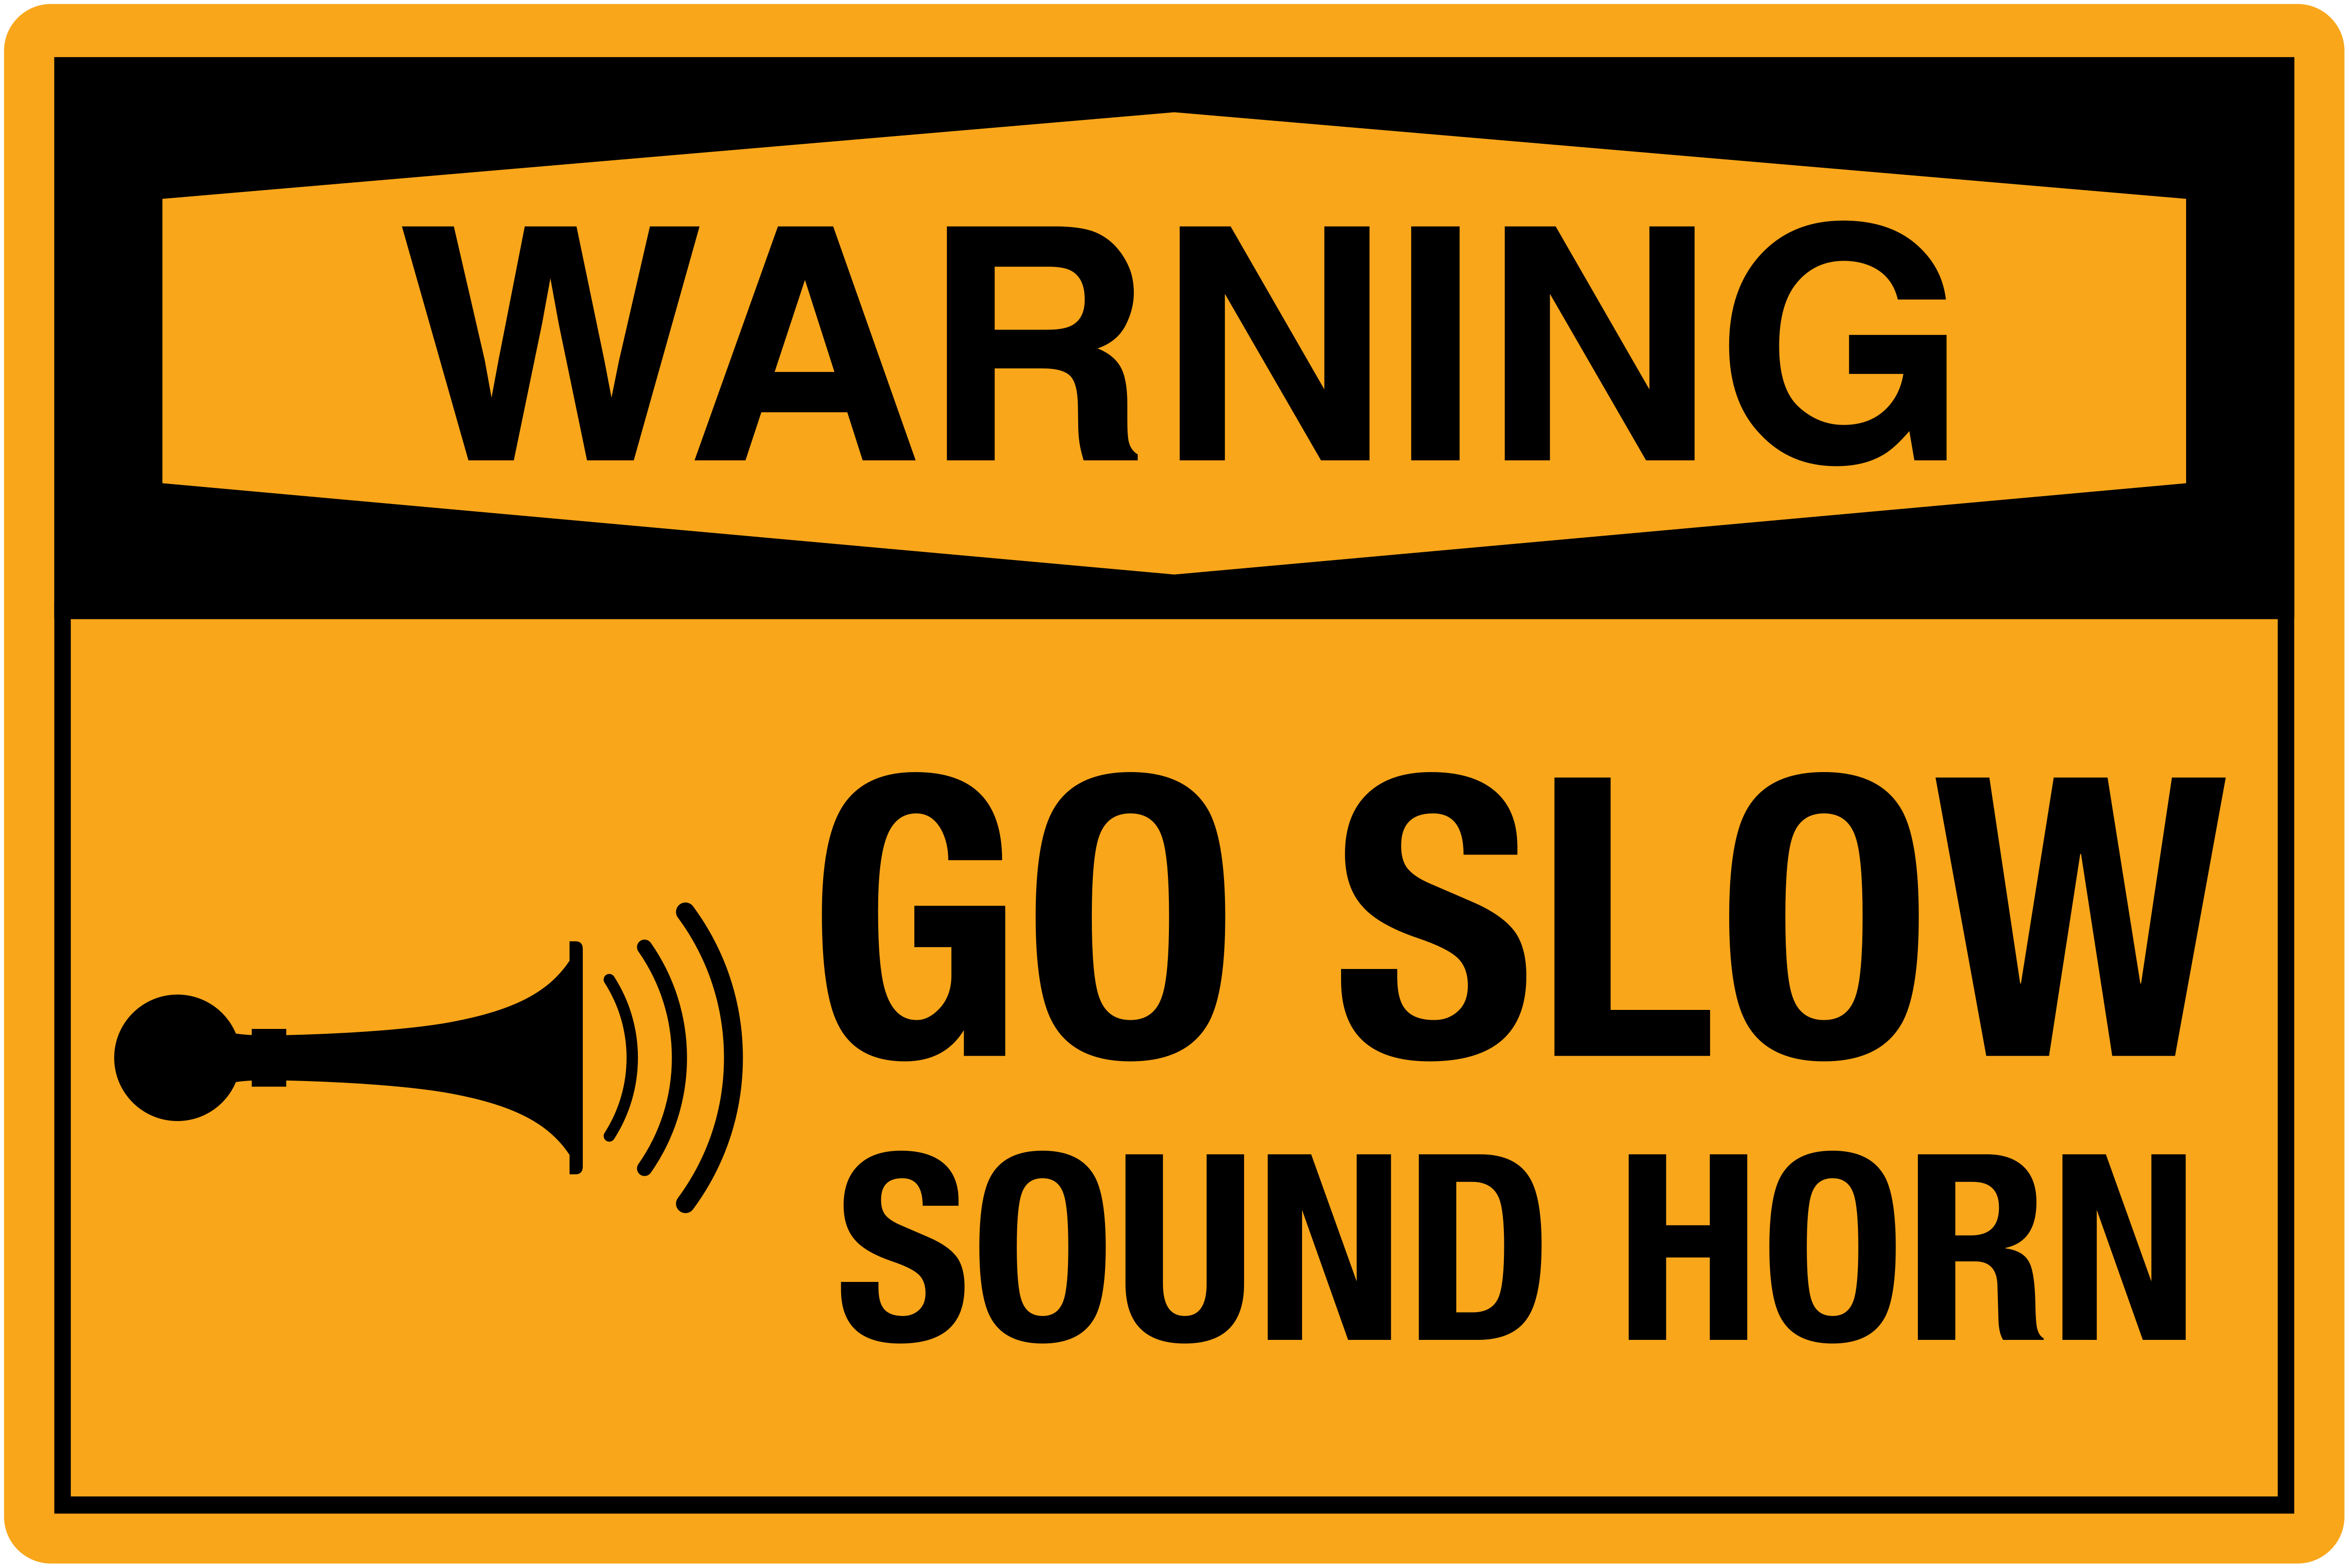 |  |  |  |  | A. Yell loudly to let people know you're driving behind them.  B. Drive fast and honk your horn so people can hear you.  C. Drive slowly and use your car horn to warn people you're nearby.  D. Use hand signals to direct traffic while your dad backs up.
Question 16: | What does the sign say?
🤔 Ask Questions Fearlessly. Curiosity fuels learning. 🔥 #CuriosityRules |  |  |  |  | A. You should rely on others to give you information.  B. You should feel empowered to inquire and learn.  C. You should suppress your curiosity at all times.  D. You should be afraid to ask anything.

Part 3. Choose the word that best fits each space in the following passage

Dear Sarah,
I know you've been feeling down lately, and I want you to know that I'm here for you. It's important to take care of our mental health, just like we care for our physical health. (17) ______ your feelings is the first step. Don't be afraid to (18) ______ to someone you trust, like a friend, family member, or teacher. They can offer (19) ______ and support. Remember, you're not alone, and there are (20) ______ resources available to help you cope with whatever you're going through. Talking to a counselor or therapist can provide you with healthy coping (21) ______ . Your mental well-being is important, so please don't hesitate to (22) ______ help when you need it.
Love,
Emily
Question 17: | A. Ignoring | B. Hiding | C. Avoiding | D. Acknowledging
Question 18: | A. talk | B. sleep | C. draw | D. sing
Question 19: | A. understanding | B. judgment | C. confusion | D. silence
Question 20: | A. few | B. much | C. little | D. many
Question 21: | A. secrets | B. mechanisms | C. problems | D. games
Question 22: | A. seek | B. ignore | C. hide | D. give

Part 4. Read the following brochure of a karaoke event. Decide whether the statements from 23 to 26 are True or False and choose the correct answer to complete the statements in question 27 and 28.

Calling all music lovers! Get ready to belt out your heart at SingFest 2024, the ultimate karaoke extravaganza!
* Unleash your inner rockstar: Whether you're a shower singer or a seasoned karaoke pro, SingFest welcomes everyone.
* Celebrate the joy of music: Sing your heart out to your favorite tunes, discover new artists, and connect with fellow music lovers.
* Support a worthy cause: All proceeds from SingFest will be donated to the Music Education Foundation, supporting music programs in underprivileged schools.
* Fun for all ages: SingFest offers a family-friendly environment with dedicated kids' karaoke sessions and entertainment.
Participation Details
* Date: August 10th & 11th, 2024
* Time: 10:00 AM - 8:00 PM
* Venue: City Hall Auditorium
* Registration fee: $20 (Adults), $10 (Kids under 12)
* On-site registration available
What to Expect
* Over 10,000 song choices across various genres
* Professional sound system and stage
* Food stalls and beverages available
* Prizes for the best performances
* Karaoke workshops for aspiring singers
For inquiries:
Email: singfest@email.com
Website: www.singfest2024.com
Question 23: | Both professional and amateur singers are welcome to perform.
 | TRUE | FALSE
Question 24: | SingFest will be held over two consecutive days.
 | TRUE | FALSE
Question 25: | Participants need to prepare their songs in advance.
 | TRUE | FALSE
Question 26: | SingFest aims to make music education accessible to all children.
 | TRUE | FALSE
Question 27: | People who attend SingFest can expect ______.
 | A. to enjoy food and drinks at the venue |  | B. to perform with a live band
 | C. to meet famous singers |  | D. to get free singing lessons
Question 28: | According to the brochure, SingFest offers ______.
 | A. a wide variety of song selections |  | B. awards for outstanding performances
 | C. guidance for those who want to improve their singing skills |  | D. backstage passes to meet the performers

Part 5. Use the correct form of the word given in each sentence.

Question 29: | The city offers a wide variety of __________________ options. (entertain)
Question 30: | Public transport is usually crowded, __________________ during rush hour. (especial)
Question 31: | The __________________ rainfall flooded the streets and caused traffic jams. (continue)
Question 32: | A cancer __________________, she now advocates for early detection. (survive)
Question 33: | The painter used __________________ media to create the artwork. (mix)
Question 34: | My school has many __________________ musicians in the orchestra. (talent)

Part 6. Look at the entry of the word "transfer" in a dictionary. Use what you can get from the entry to complete the sentences with two or three words.

Type: verb or noun
Syllables: trans-fer
UK: /ˈtræns.fɜːr/
US: /ˈtræns.fɝː/
Definition:
1. (verb) Move something/somebody from one place to another.
2. (noun) An act of transferring something/somebody.
Examples:
* Students transferring schools
* Transfer the data to a memory stick.
* I'll need your bank details to arrange a bank transfer.
* The team's star player requested a transfer request before the deadline.
Question 35: | My friend is __________________ to a new school across the country.
Question 36: | To send money to my family, I need to initiate a __________________ through my online banking.

Part 7. Rewrite each of the following sentences in another way so that it means almost the same as the sentence printed before it.

Question 37: | They will have to create a plan by Friday. ➡ A plan will ______
 | ___________________________________________________________________________________
Question 38: | Lucy rarely drinks coffee in the evening. ➡ It's rare for ______
 | ___________________________________________________________________________________
Question 39: | The view from the top of the mountain is breathtaking. ➡ It's breathtaking ______
 | ___________________________________________________________________________________
Question 40: | The library closes at 6 p.m. on Saturdays. ➡ On Saturdays, the ______
 | ___________________________________________________________________________________

------------------------------ THE END ------------------------------

ĐÁP ÁN

Câu | 1 | 2 | 3 | 4 | 5 | 6 | 7 | 8 | 9 | 10
Chọn | B | C | A | C | A | C | C | C | A | A
Câu | 11 | 12 | 13 | 14 | 15 | 16 | 17 | 18 | 19 | 20
Chọn | B | A | D | A | C | B | D | A | A | D
Câu | 21 | 22 | 23 | 24 | 25 | 26 | 27 | 28
Chọn | B | A | True | True | False | True | A | D

Câu 29. entertainment
Câu 30. especially
Câu 31. continuous
Câu 32. survivor
Câu 33. mixed
Câu 34. talented
Câu 35. transferring schools
Câu 36. bank transfer
Câu 37. A plan will have to be created by them by Friday.
Câu 38. It's rare for Lucy to drink coffee in the evening.
Câu 39. It's breathtaking to see the view from the top of the mountain.
Câu 40. On Saturdays, the library closes at 6 p.m.

