DETHIANH.COM  Miễn phí - Đề thi thử số 7  Cập nhật ngày 16/05/2025 | HÀ NỘI | ĐỀ THI THỬ VÀO LỚP 10 NĂM 2025  MÔN: TIẾNG ANH  Thời gian làm bài 60 phút, không kể thời gian phát đề.  _____

Part 1. Choose the word whose underlined part differs from that of the other three in pronunciation in each of the following questions.
Question 1: | A. |a|head | B. form|a|l | C. dist|a|nt | D. us|a|ge
Question 2: | A. fin|g|er | B. le|g|al | C. ar|g|ue | D. sug|g|est

Part 2. Choose the word that differs from the other three in the position of primary stress in each of the following questions.
Question 3: | A. upgrade | B. response | C. access | D. assume
Question 4: | A. enable | B. hesitate | C. serious | D. chronicle

Part 3. Choose the correct answer to each of the following questions.
Question 5: | The sudden downpour ______ the children playing in the park, forcing them to run for cover.
 | A. soaked | B. amused | C. scattered | D. gathered
Question 6: | Someday, people ______ to the moon for vacations.
 | A. travel | B. will travel | C. will travels | D. traveled
Question 7: | My little sister sings ______ my older brother. They are both terrible!
 | A. bad | B. as badly as | C. worse than | D. the worst
Question 8: | If she ______ her homework, she ______ to the party.
 | A. finishes - can go | B. finished - could go | C. finishes - could go | D. will finish - can go
Question 9: | Lan is lost trying to find the post office. She sees a woman, Sarah, and asks for directions.  Lan: "Excuse me, could you please tell me how to get to the post office?"  Sarah: "______"
 | A. I'm not sure I understand your question. | B. Do you need to send a letter? | C. Of course. Turn left at the corner, then it's on your right. | D. The post office is closed on Sundays.
Question 10: | The manager, ______ I had spoken to on the phone, was very helpful.
 | A. whose | B. who | C. whom | D. which
Question 11: | She felt ______ after a long hike in the mountains.
 | A. blue | B. circular | C. silent | D. tired
Question 12: | ______ cultures have unique traditions and customs.
 | A. Many | B. Amount of | C. Much | D. Number

Part 4. Read the following instruction and choose the correct option that best fits each of the numbered blanks from 13 to 16.

HOW TO BUILD SELF-CONFIDENCE
1. Think about your strengths and write them (13) ______.
2. Be kind to yourself, especially when you make (14) ______ mistake.
3. (15) ______ realistic goals and work towards them step by step.
4. Celebrate your achievements, no matter how small they are. Don't be afraid to be (16) ______ of yourself!

Question 13: | A. out | B. down | C. up | D. off
Question 14: | A. the | B. x (no article) | C. an | D. a
Question 15: | A. Build | B. Set | C. Make | D. Fix
Question 16: | A. proudly | B. proud | C. prouder | D. pride

Part 5. Choose the correct answer to each of the following questions from 17 to 18.

Question 17: | Choose the correct order of sentences a, b, and c.
The Gift of Time
My parents both work very hard, and we rarely have time together as a family.
a. I knew material gifts wouldn't mean as much as quality time.
b. For Father's Day, I wanted to give my dad something special.
c. I planned a whole day of activities we could enjoy together, like fishing and hiking.
 | A. c - b - a | B. a - c - b | C. b - a - c | D. c - a - b
Question 18: | Choose the sentence that most appropriately ends the text in Question 17.
A. We ended up having pizza delivered, which we both enjoyed.
B. Next year, I hope we can go on a real vacation somewhere new.
C. My father said it was the best Father's Day he could remember.
D. It was a simple gift, but it meant the world to both of us.

Part 6. Choose the correct option that best fits each of the numbered blanks from 19 to 24.

The Genius of Leonardo
Leonardo da Vinci was (19) ______ artist, scientist, and inventor during the Italian Renaissance. He is best known for his paintings, (20) ______ the Mona Lisa and The Last Supper remain two of the most famous and admired artworks in the world. Leonardo possessed (21) ______ curiosity and a thirst for knowledge, leading him to study a wide range of subjects from anatomy and astronomy to engineering and botany.
He filled numerous notebooks with inventions, observations, and theories, (22) ______ demonstrated his belief that art and science were deeply interconnected. Although only a few of his inventions, like flying machines, were built during his lifetime, his detailed drawings and notes continued (23) ______ future generations of artists, thinkers, and creators. It is this unique blend of talent, curiosity, and forward-thinking that makes Leonardo da Vinci (24) ______ such an influential figure even today.

Question 19: | A. an exceptional | B. exceptional an | C. an exceptionally | D. exceptionally
Question 20: | A. which | B. of which | C. by which | D. from which
Question 21: | A. an insatiably | B. insatiable an | C. an insatiable | D. insatiable
Question 22: | A. , however, | B. which | C. that | D. and
Question 23: | A. inspiring | B. for inspiring | C. to inspire | D. to be inspired
Question 24: | A. remaining | B. remained | C. remain | D. to remain

Part 7. Choose the sentence that is CLOSEST in meaning to the original sentence in each of the following questions.

Question 25: | "Last time I checked, the door was locked," he reminded me.
A. He reminded me that the last time he had checked, the door had been locked.
B. He reminded me that the last time I had checked, the door had been locked.
C. He reminded me that the last time he had checked, the door was locked.
D. He reminded me that last time he checked, the door was locked.
Question 26: | I'm not really into listening to rock music.
A. I think rock music is too loud.
B. Rock music isn't really my preferred genre.
C. I don't listen to rock music very often.
D. I'm not understanding rock music very well.

Part 8. Choose the sentence that is made from the given cues in each of the following questions.

Question 27: | The police / work / tirelessly / track / the missing person.
A. The police worked tirelessly to track for the missing person.
B. The police worked tirelessly to track down the missing person.
C. The police worked tirelessly to track on the missing person.
D. The police worked tirelessly to track up the missing person.
Question 28: | I / enjoy / cook / dinner / family.
A. I enjoy cooking dinner of my family.
B. I enjoy to cook dinner to my family.
C. I enjoying cook dinner for my family.
D. I enjoy cooking dinner for my family.

Part 9. Read the following sign or notice and choose the correct answer to each of the following questions.

Question 29: | You are sorting your trash. Which of these items should you put in a bin with this sign?
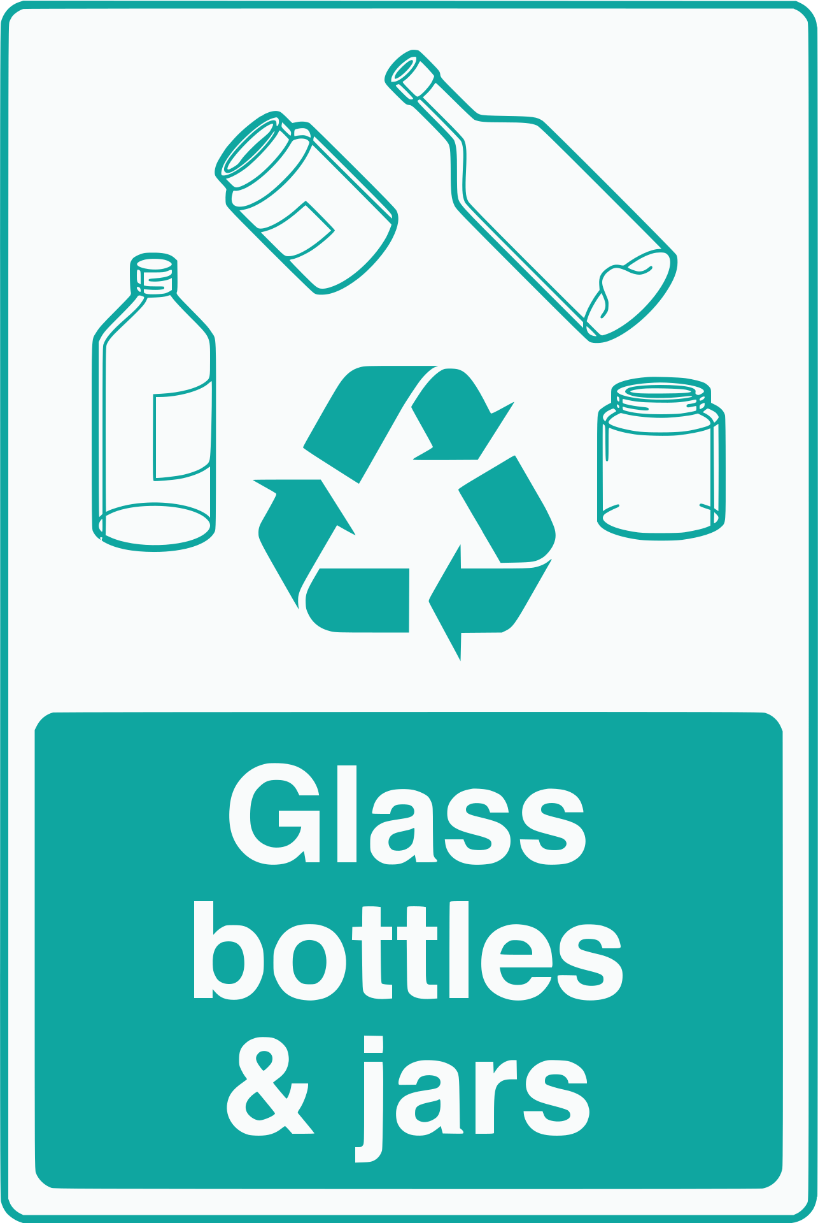 |  |  |  |  | A. Used paper and cardboard.  B. Empty plastic bottles.  C. Empty glass containers.  D. Metal cans and tins.
Question 30: | What does this notice encourage people to do?
No littering. Keep our city clean. |  |  |  |  | A. Littering is allowed in designated areas.  B. There are no consequences for littering.  C. Dispose of their trash responsibly and maintain a clean environment.  D. The city is responsible for cleaning up litter.

Part 10. Read the following passage and choose the correct answer to each of the following questions from 31 to 36.

London and New York City, two of the world's most iconic metropolises, offer diverse experiences, particularly in their public transportation systems. While both cities |boast| extensive networks, they differ in their history, design, and overall feel.
London's Underground, affectionately nicknamed the "Tube", dates back to the 19th century, making it the oldest underground railway system globally. Its labyrinthine tunnels reflect the city's historical development, with some lines being narrow and congested. In contrast, New York City's subway system, though vast, is relatively newer. Its grid-like layout, reflecting the city's modern grid street plan, makes navigation comparatively straightforward.
Beyond their layouts, the two systems differ in their ambiance. London's Tube, with its deep tunnels and often dimly lit stations, can feel somewhat |somber|. Conversely, New York's subway, with its bustling stations adorned with colorful artwork and performances by local artists, exudes a vibrant, energetic atmosphere.
Despite their differences, both systems provide efficient and affordable transportation to millions of commuters daily. Whether navigating London's historical depths or experiencing the artistic energy of New York's subway, each system offers a unique perspective on city life.

Question 31: | What is the main topic of the passage?
A. The cultural differences between London and New York City.
B. The history of London and New York City.
C. The best way to travel in London and New York City.
D. The differences and similarities between the public transportation systems of London and New York City.
Question 32: | The word "boast" in paragraph 1 is CLOSEST in meaning to ______.
 | A. dislike | B. need | C. are proud to have | D. exaggerate
Question 33: | What makes navigating the New York City subway system easier?
 | A. Its artwork | B. Its age | C. Its grid-like layout | D. Its crowdedness
Question 34: | Which aspect of the London Underground is NOT mentioned in the text?
 | A. The tunnel size | B. The age | C. The lighting | D. The ticket prices
Question 35: | According to the text, what is a similarity between the London and New York City public transportation systems?
A. They both have a similar atmosphere.
B. They both feature historical artifacts.
C. They both provide affordable transportation for many people.
D. They both have the same layout.
Question 36: | The word "somber" in paragraph 3 is OPPOSITE in meaning to ______.
 | A. lively | B. dark | C. deep | D. quiet

Part 11. Four phrases/sentences have been removed from the text below. For each question, choose A, B, C, or D to indicate the correct option that best fits each of the numbered blanks from 37 to 40.

The Pyramids of Giza are among the most recognizable structures in the world. (37) ______, they stand as a testament to the ingenuity and architectural prowess of the ancient Egyptians. Built as elaborate tombs for the pharaohs, the pyramids were constructed over thousands of years, with each pyramid representing a different ruler.
The largest of the three main pyramids at Giza is the Great Pyramid of Khufu. (38) ______. Inside the pyramid, a complex network of chambers and passages leads to the King's Chamber, where Khufu's sarcophagus rests.
The pyramids were not only burial places, (39) ______. They were also massive construction projects that required the labor of thousands of skilled workers, demonstrating the pharaoh's power and influence.
Today, the Pyramids of Giza continue to fascinate and inspire awe in visitors from around the globe. (40) ______, they remain a testament to the enduring legacy of ancient Egypt and a source of endless wonder for generations to come.
A. As one of the Seven Wonders of the Ancient World
B. but also powerful symbols of religious belief
C. It is believed to have been completed around 2560 BC.
D. Constructed thousands of years ago

Question 37: __________ | Question 38: __________ | Question 39: __________ | Question 40: __________

------------------------------ THE END ------------------------------

ĐÁP ÁN

Câu | 1 | 2 | 3 | 4 | 5 | 6 | 7 | 8 | 9 | 10
Chọn | D | D | C | A | C | B | B | A | C | C
Câu | 11 | 12 | 13 | 14 | 15 | 16 | 17 | 18 | 19 | 20
Chọn | D | A | B | D | B | B | C | D | A | B
Câu | 21 | 22 | 23 | 24 | 25 | 26 | 27 | 28 | 29 | 30
Chọn | C | B | C | C | A | B | B | D | C | C
Câu | 31 | 32 | 33 | 34 | 35 | 36 | 37 | 38 | 39 | 40
Chọn | D | C | C | D | C | A | D | C | B | A

