DETHIANH.COM  Miễn phí - Đề thi thử số 10  Cập nhật ngày 16/05/2025 | HÀ NỘI | ĐỀ THI THỬ VÀO LỚP 10 NĂM 2025  MÔN: TIẾNG ANH  Thời gian làm bài 60 phút, không kể thời gian phát đề.  _____

Part 1. Choose the word whose underlined part differs from that of the other three in pronunciation in each of the following questions.
Question 1: | A. w|i|ndow | B. |i|ntend | C. ent|i|re | D. read|i|ng
Question 2: | A. criti|c|al | B. wel|c|ome | C. |c|olor | D. so|c|ially

Part 2. Choose the word that differs from the other three in the position of primary stress in each of the following questions.
Question 3: | A. update | B. combat | C. descend | D. disclose
Question 4: | A. saturday | B. halloween | C. manager | D. ignorance

Part 3. Choose the correct answer to each of the following questions.
Question 5: | The ______ conflict between the two countries lasted for decades and had a profound impact on the region's history.
 | A. protracted | B. transient | C. ephemeral | D. fleeting
Question 6: | I ______ three whole pizzas by myself! I'm so full.
 | A. am eating | B. ate | C. have eaten | D. has eaten
Question 7: | Blue whales are ______ animals on Earth.
 | A. most large | B. the largest | C. larger | D. large
Question 8: | If she ______ more time with her family, she ______ happier.
 | A. had spent - would have been | B. spends - will be | C. spent - would be | D. will spend - is
Question 9: | Ngoc is having trouble opening her locker at school. She sees her classmate, William.  Ngoc: "This locker is stuck. ______"  William: "Let me try. Maybe I can get it open."
 | A. What's wrong with this locker? | B. Could you give me a hand with it? | C. Do you have a locker? | D. I need to get my books.
Question 10: | We were living in Hanoi ______ the pandemic started.
 | A. when | B. whose | C. which | D. who
Question 11: | After missing the winning goal, Nam was ______ with himself for the rest of the game.
 | A. angry | B. eager | C. delighted | D. content
Question 12: | We saw ______ interesting sights on our trip.
 | A. lot | B. a many | C. a lot of | D. much

Part 4. Read the following instruction and choose the correct option that best fits each of the numbered blanks from 13 to 16.

HOW TO STAY HYDRATED
1. Carry a reusable water bottle with you (13) ______ the day.
2. Drink water before, during, and after physical activity.
3. (14) ______ water over sugary drinks like soda.
4. Eat fruits and vegetables, as they contain (15) ______ lot of water.
5. Drink water when you feel (16) ______, don't wait until you're dehydrated.
6. If you have any medical conditions, consult your doctor about proper hydration.

Question 13: | A. around | B. during | C. throughout | D. before
Question 14: | A. Choose | B. Avoid | C. Drink | D. Prefer
Question 15: | A. the | B. an | C. x (no article) | D. a
Question 16: | A. tired | B. thirsty | C. sleepy | D. hunger

Part 5. Choose the correct answer to each of the following questions from 17 to 18.

Question 17: | Choose the correct order of sentences a, b, and c.
The Unwanted Advice
My friend gave me unsolicited advice that really annoyed me.
a. I felt my anger rising, but I decided to communicate calmly and honestly.
b. Instead of listening, she kept interrupting with advice I didn't want.
c. I was telling my friend about a personal problem I was facing.
 | A. c - a - b | B. b - c - a | C. b - a - c | D. c - b - a
Question 18: | Choose the sentence that most appropriately ends the text in Question 17.
A. My friend eventually understood and apologized for giving too much advice.
B. She got upset with me because I didn't appreciate her trying to help.
C. I decided it was best to avoid talking to her about my problems in the future.
D. I told her I appreciated her concern but needed to figure things out on my own.

Part 6. Choose the correct option that best fits each of the numbered blanks from 19 to 24.

A Day at the Art Gallery
Visiting an art museum can be (19) ______ rewarding experience. There are (20) ______ different styles of art to see, from ancient sculptures to modern paintings. You can learn about different cultures and time periods by observing the art created during those times. Many museums offer guided tours or audio guides, which can enhance your understanding and appreciation of the artworks.
However, there are (21) ______ things to keep in mind when you visit a museum. Remember (22) ______ photos without permission is often prohibited. It's important to be respectful of the art and other visitors by not touching the exhibits or talking loudly. Finally, take your time and don't try (23) ______ everything at once. Choose a few areas or artists that interest you and focus on those. This will make your visit (24) ______ enjoyable.

Question 19: | A. a truly | B. a truely | C. truly | D. truly a
Question 20: | A. many | B. much | C. any | D. a lot
Question 21: | A. few | B. little | C. a little | D. a few
Question 22: | A. taking | B. took | C. to take | D. take
Question 23: | A. see | B. saw | C. seeing | D. to see
Question 24: | A. more than | B. most | C. the most | D. more

Part 7. Choose the sentence that is CLOSEST in meaning to the original sentence in each of the following questions.

Question 25: | "I was just trying to help," he said, holding up these muddy gardening gloves.
A. He said that I had just been trying to help, holding up these muddy gardening gloves.
B. He said that he was just trying to help, holding up those muddy gardening gloves.
C. He said that he had just been trying to help, holding up those muddy gardening gloves.
D. He said that he was just trying to help, holding up these muddy gardening gloves.
Question 26: | I need you to help me with my homework.
A. Could you please help me with my homework?
B. Why don't you help me with my homework?
C. How about you help me with my homework?
D. Do you help me with my homework?

Part 8. Choose the sentence that is made from the given cues in each of the following questions.

Question 27: | You / count / me / be / there / you.
A. You can count with me to be there for you.
B. You can count of me to be there for you.
C. You can count me to be there for you.
D. You can count on me to be there for you.
Question 28: | I / accustomed / cook / dinner / family.
A. I am accustomed cook dinner to my family.
B. I am accustomed to cooking dinner for my family.
C. I am accustomed to cooking dinner with for family.
D. I accustomed to cooking dinner of my family.

Part 9. Read the following sign or notice and choose the correct answer to each of the following questions.

Question 29: | You are working on a science project and need to dispose of some old chemicals. You see the sign below on a container. What does this sign tell you about the container?
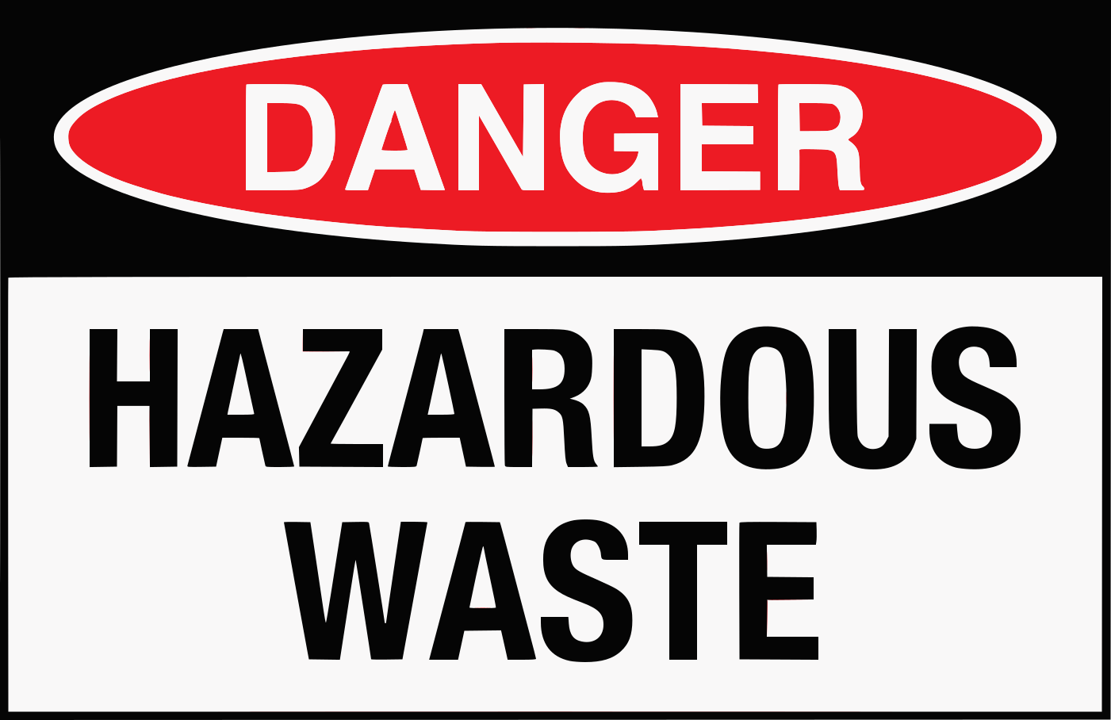 |  |  |  |  | A. The container is empty and can be used for storage.  B. The container has dangerous waste in it.  C. The container is full of safe materials.  D. The container is for storing food scraps.
Question 30: | What does this notice imply about the sneakers?
Limited edition sneakers available now! First come, first served. |  |  |  |  | A. The sneakers are designed by a famous celebrity.  B. You can only buy the sneakers online.  C. There are not enough sneakers for everyone who wants them.  D. The price of the sneakers will increase later.

Part 10. Read the following passage and choose the correct answer to each of the following questions from 31 to 36.

Paris Saint-Germain, commonly known as PSG, is a |renowned| French football club based in Paris. Founded in 1970, the club quickly rose to prominence in French football, becoming a symbol of Parisian pride and ambition. Initially known for its passionate fans and distinctive blue and red kits, PSG struggled to achieve consistent success in its early years.
However, everything changed in the 21st century. In 2011, a Qatari investment group acquired the club, injecting significant financial resources. This takeover transformed PSG into one of the wealthiest clubs globally, enabling them to attract world-class players like Zlatan Ibrahimović, Neymar Jr., and Kylian Mbappé.
With these star players, PSG dominated French football, winning numerous Ligue 1 titles and domestic cups. Their success extended to European competitions, where they consistently reached the knockout stages of the UEFA Champions League. Though they haven't lifted the |coveted| Champions League trophy yet, their consistent presence among Europe's elite showcases their newfound status as a European powerhouse.
Despite criticisms regarding their financial dominance, PSG's impact on French football is undeniable. They elevated the league's global profile, attracted international fans, and inspired a new generation of young French players. Their journey, marked by early struggles and recent triumphs, embodies the club's motto: "Dream Bigger."

Question 31: | What is the main topic of this reading passage?
A. The history of the UEFA Champions League.
B. The history and rise of Paris Saint-Germain football club.
C. The life of famous PSG players.
D. The rules of French football.
Question 32: | The word "renowned" in paragraph 1 is CLOSEST in meaning to ______.
 | A. local | B. small | C. famous | D. unknown
Question 33: | What event marked a turning point in PSG's history according to the passage?
 | A. The construction of their stadium. | B. The acquisition by a Qatari investment group. | C. The club's foundation in 1970. | D. The signing of their first foreign player.
Question 34: | Which of these statements about PSG is NOT mentioned in the text?
 | A. PSG has won the UEFA Champions League multiple times. | B. PSG has a large and passionate fan base. | C. PSG has attracted some of the world's best players. | D. PSG has faced criticism for its financial power.
Question 35: | How has PSG impacted French football?
A. Increased global attention and inspired young players.
B. Led to financial instability in French football.
C. Reduced the number of French players in the league.
D. Decreased the popularity of other French teams.
Question 36: | The word "coveted" in paragraph 3 is OPPOSITE in meaning to ______.
 | A. undesirable | B. prestigious | C. sought-after | D. desired

Part 11. Four phrases/sentences have been removed from the text below. For each question, choose A, B, C, or D to indicate the correct option that best fits each of the numbered blanks from 37 to 40.

The Himalayas, home to the world's highest peaks, attract adventurers seeking challenging treks. (37) ______ is the Everest Base Camp Trek, a journey through breathtaking landscapes and unique Sherpa culture.
This trek, typically lasting around two weeks, begins in Lukhpla, a small town with an airstrip serving as the gateway to the Everest region. (38) ______. Along the way, trekkers encounter suspension bridges over rushing rivers, colorful prayer flags fluttering in the wind, and ancient monasteries offering glimpses into Tibetan Buddhism.
Acclimatizing to the altitude is crucial, as trekkers ascend to heights exceeding 5,000 meters. (39) ______, experiencing headaches, nausea, or fatigue. Proper hydration and pacing are essential for a safe and enjoyable trek.
Reaching Everest Base Camp is a truly remarkable achievement, offering unparalleled views of Mount Everest and surrounding peaks. (40) ______, the experience of trekking through the Himalayas, with its physical demands and cultural immersion, leaves a lasting impression on those fortunate enough to undertake it.
A. From there, trekkers follow trails winding through rhododendron forests and across high-altitude deserts.
B. Among the most popular options
C. While not everyone reaches the summit
D. It's common for trekkers to feel the effects of altitude sickness

Question 37: __________ | Question 38: __________ | Question 39: __________ | Question 40: __________

------------------------------ THE END ------------------------------

ĐÁP ÁN

Câu | 1 | 2 | 3 | 4 | 5 | 6 | 7 | 8 | 9 | 10
Chọn | C | D | B | B | A | C | B | C | B | A
Câu | 11 | 12 | 13 | 14 | 15 | 16 | 17 | 18 | 19 | 20
Chọn | A | C | C | A | D | B | D | D | A | A
Câu | 21 | 22 | 23 | 24 | 25 | 26 | 27 | 28 | 29 | 30
Chọn | D | C | D | D | C | A | D | B | B | C
Câu | 31 | 32 | 33 | 34 | 35 | 36 | 37 | 38 | 39 | 40
Chọn | B | C | B | A | A | A | B | A | D | C

